The non-publishability theorem of the proof of Goldbach’s conjecture
or
A story about the possibility of mathematics not being an exact science after all

Dénes, Tamás – mathematician (Budapest, Hungary)
email: tdenest@freemail.hu

“Sometimes it is the people no one can imagine anything of who

do the things no one can imagine.”
(A. M. Turing)

On the one hand, I am the protagonist of the following story, but I am also its modest chronicler. Thus, all characters in the story, as well as the documents contained in the appendices, are real. In our increasingly virtualized world, it might seem strange to read such a REAL STORY. Yet, it is important that I put it down and share it, as it represents the aristocratic reality of today’s scientific world (specifically the realm of mathematics), which we had seemed to have left behind in the second part of the 20th century, with the golden age of a new Enlightenment upon us. We were hoping for the revival of the age of Enlightenment, when the hierarchy of feudal interests was overwritten by new ideas, by the notion of the beauty inherent to new insights.
“The Theorem can be likened to a pearl, and the method of proof to an oyster. The pearl is prized for its luster and simplicity; the oyster is a complex living beast whose innards give rise to this mysteriously simple gem.” (D.R. Hofstadter, 1945–, American mathematician, historian of mathematics)

This story starts at the turn of the millennium, when in 2001 I published my Complementary Prime-Sieve theorem in the PU.M.A journal (T. Dénes, 2001). In a nutshell, this is a new kind of complementary approach to the prime-function. That is, if we cannot directly determine the specific characteristics describing prime numbers, we should do this for composite numbers, the complementary set of which is the set of prime numbers.
My 2001 paper cited above remained fully unnoticed. Yet, in 2017, I managed to prove an interesting theorem with the help of this new approach. I named it the Symmetric Prime Number theorem:
To each N≥4 natural number exist m_{N} ≥ 0 natural number, so that p_{N-}=N-m_{N} and p_{N+}=N+m_{N} are prime numbers.

Although I never intended to prove Goldbach’s conjecture, I was surprised to see that it directly follows from my Symmetric Prime Number theorem. Thus, I wrote an article about this, which of course I wanted to get published. This was even more so, as I was convinced that even if my theorem had not been of much interest, the proof of the 275 years old Goldbach’s conjecture would definitely be. After all, a whole repository of books deal with the extraordinary difficulty of proving Goldbach’s conjecture, and the approximating solutions of significant researchers. Thus, I gave the following title to my article: Dénes type Symmetric Prime Number theorem and its application to proof of the Even Goldbach conjecture (Dénes, Tamás, 2017).

For me, this marked the beginning of a still ongoing story: the (non)publishability of the proof of Goldbach’s conjecture. This I would like to share with you, dear Reader, for two reasons. On the one hand, as a lesson for those who don’t have an “established” path for publishing their scientific findings.
On the other hand, there is the fact that during these well-nigh surreal years of this story, my manuscript has been left partly without any mathematical assessment, and partly without any response by the professional journals and the professors of mathematics involved in this field. Thus, the question raised in the title arose: is mathematics possibly not an exact science after all?
Namely, as far as I know, proof is not only of outstanding importance in mathematics, but it can also be clearly assessed whether a proof is complete, and whether it is erroneous or correct. Thus, neither the erroneousness, nor its correctness is a matter of faith, and it is definitely not dependent on whose head it was conceived in. I was shocked by that the only acclaimed professor of mathematics who did me the honor of reading my article containing the proof described above did not cite any errors, but wrote this in his review: “I believe Goldbach’s conjecture may not be proven via such methods.”

I attempted to have my article published by renowned international journals and sent it for review to internationally acclaimed professors of number theory between 2017 and 2019. These 17 attempts to get published are summarized in the below table, where the attempts are put into chronological order by the date of first contact. I will continue by briefly describing the story of each exchange referring to its number in this table, complemented by the original correspondence included in the appendices with the time stamp of the letters and the accurate identification of the journal, or the scholar. As my intention to have my article published was public, I do believe that the – many times shocking – answers received also qualify as public, so no personality rights are infringed by their publication.

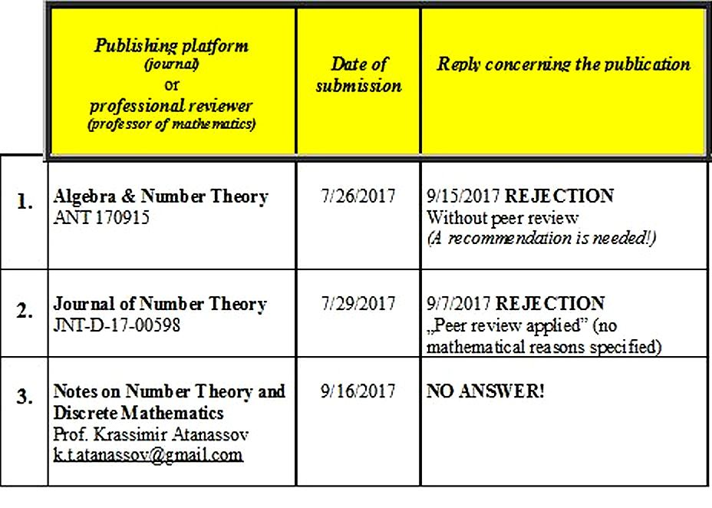

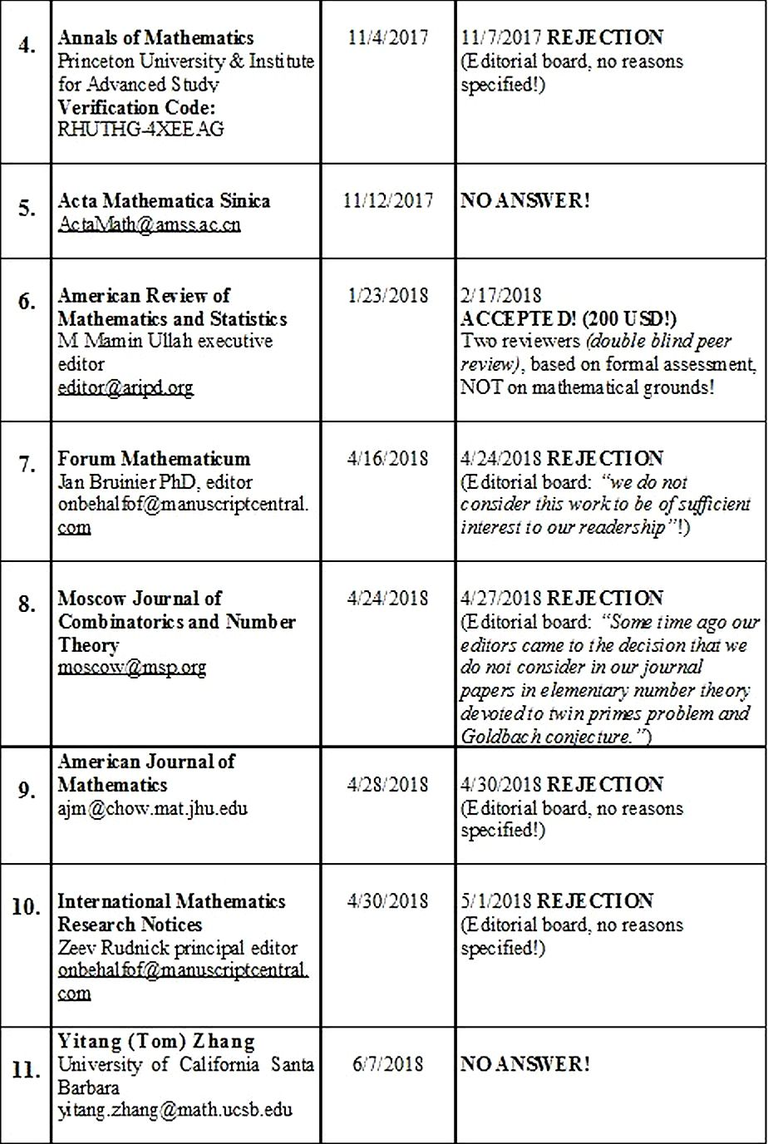

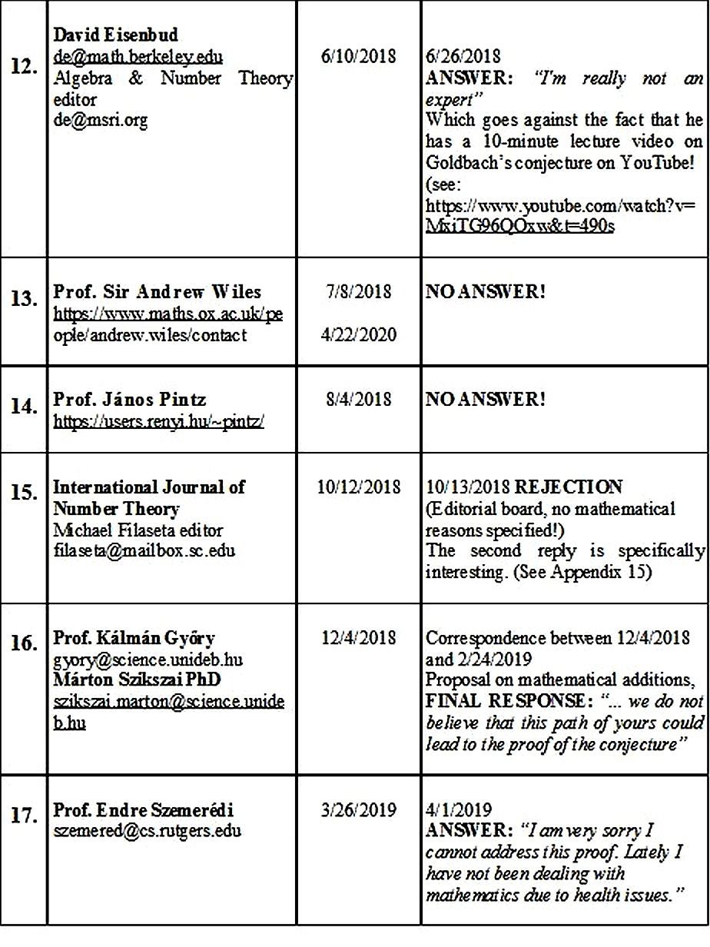

1. Algebra & Number Theory

The journal Algebra & Number Theory writes the following about the review process of the submitted manuscripts (see: https://msp.org/ant/about/journal/about.html): “Based on peer-review reports, the articles are accepted or rejected by the editorial board, which contains experts in many subfields, through a process of online discussion and consensus.”
In contrast, in the case of my article, publication was rejected with the following comment (for full text, see Appendix 1):
“If you are convinced that your solution is correct, and wish to continue to pursue publication, then you should have someone else (for instance a mathematically literate friend or colleague, or perhaps a mathematician at a local university) read your manuscript.”

This reasoning is difficult to interpret in the light of the following declaration of impartiality of the journal (see https://msp.org/ant/about/journal/about.html):
“Impartiality Statement
The purpose of Algebra & Number Theory is the advancement of mathematics. Editors evaluate submitted papers strictly on the basis of scientific merit with the help of peer review reports, without regard to authors’ nationality, country of residence, institutional affiliation, gender, ethnic origin, religion, or political views.”

2. Journal of Number Theory
The letter of rejection from the editorial board of course refers to the reviewers:
“For your guidance, we append the reviewers' comments below.”

However, the reviewers’ opinion presented in Appendix 2 does not include any mathematical justifications beyond some general comments. I leave it to the reader to decide whether, in the case of a mathematical article containing a specific theorem and proof, it is an exact opinion to merely refer to a quote from Feynman instead of any specific mathematical arguments? The “thoroughness” of the reviewers (or the editor) is also evident in that even Feynman’s name is misspelled (see App2).
The question arises:
what would this same reviewer (or editor) say if he or she was not attended to for example in a car dealership? Or if the merchant said merely: “I don’t think you have that much money.” ... I am ready to acknowledge that the analogue is a little off, as commerce is not an exact science, like mathematics.

4. Annals of Mathematics (Princeton University & Institute for Advanced Study)

Referring to an expert, the editorial board replied with the following rejection (without providing any justification): “The expert consulted has determined that the paper is not suitable for the Annals.”

I believe that this response is unworthy of the journal published by one of the most prestigious universities in the world. Namely, if the justification “not suitable for the Annals” is interpreted (with good intentions) as not being in line with the profile of the journal, this is not supported by the Submission Guidelines (https://annals.math.princeton.edu/submission-guidelines), which does not include any restrictions on mathematical fields besides the detailed formatting requirements.

6. American Review of Mathematics and Statistics

It seemed that my more than half-year-long, persistent publication efforts were rewarded by this sixth journal, when the editorial board notified me of the acceptance of my article. The credibility of the decision was enhanced by the fact that the evaluation sheets of the two independent experts (double blind peer review) were also attached (of course, anonymously).
I found it a little odd that the evaluation criteria concerned mostly editorial aspects rather than the mathematical content. My suspicions were enhanced by the comments of the two reviewers.
Reviewer-1: “Literature review is adequate. … Data analysis methods are praiseworthy.”
This I found strange, because I had only one reference attached to my article: after all, I used only my own 2001 article for the proof. On the other hand, there is no “data analysis” in my article, so I found the part praising my “data analysis methods” to explicitly lack credibility.

Reviewer-2: “The study is a timely research. … Objectives are consistent with literature review and analysis.”
The “timeliness” of the paper cannot really be interpreted for a 275 years old conjecture. As for the comment regarding the “literature review,” I have already made my point above, at Reviewer-1.

The dubious praise and the willingness of the editorial board to publish my work on this basis became all clear, when I came upon the attached documents specifying the USD 200 publication fee and the elaborated description of the payment terms.
I am aware of that the conditions for publication have changed since the 20th century, when not only a large number of offprints were given to the authors of their own articles (free of charge), but the journals also paid royalties, as the authors of each issue were considered to be co-authors of the journal. After all, just like in the case of books, a journal is the more valuable the more important the articles it includes. Although the latter comment is still valid today, scientific journals have also partly become business enterprises. Thus, they expect their authors to contribute to their costs. Yet, USD 200 for an 8-page article looks a bit over-priced!
Since it is a rare occurrence in the life of a journal that it could publish the proof of the problem unsolved for 275 years, and since I tried to take the reviewer’s praise seriously, I wrote this all down in a letter addressed to the editorial board. I offered the exclusive rights for publication to the journal, in case they make an exception and forego the USD 200 publication fee, which I would not otherwise be able to pay from my small pension.
Well, the editorial board left this without any replies (not even a polite refusal). Much to my regret, this made me see the “publication proposal” of the editorial board absolutely discredited.

7. Forum Mathematicum

I also contacted this journal based on their self-presentation:
“Forum Mathematicum (FORUM) is a general mathematics journal, which is devoted to the publication of research articles in all fields of pure and applied mathematics, including mathematical physics. Forum Mathematicum belongs to the top 50 journals in pure and applied mathematics, as measured by citation impact.”
On this basis (perhaps rightfully) I was surprised by the letter of rejection from the editor, which contains no mathematical justifications whatsoever, but closes on this note:
“Although we appreciate your scientific efforts represented by this work, I regret to inform you that we do not consider this work to be of sufficient interest to our readership to warrant publication.”
I leave it to the Reader to decide whether the publication of the proof for the almost 300 years of Goldbach’s conjecture is really of not “sufficient interest to our readership”?

8. Moscow Journal of Combinatorics and Number Theory

This journal managed to reject my article quicker than the previous ones (within 2 days) and in a much simpler way:
“Some time ago our editors came to the decision that we do not consider in our journal papers in elementary number theory devoted to twin primes problem and Goldbach conjecture.”

9. American Journal of Mathematics
This journal also rejected publishing my article rather quickly (within 2 days), simply using the “we regret to inform you” formula, WITHOUT JUSTIFICATION.

10. International Mathematics Research Notices

This journal also rejected publishing my article rather quickly (within 2 days), simply using the “we regret to inform you” formula, WITHOUT JUSTIFICATION.

After nearly 1 year spent with the above 10 publication attempts, I came to the conclusion that even for prestigious journals, it is too much responsibility to undertake publishing the proof of a well-known conjecture unproven for almost 300 years. Still, it was difficult for me to understand how they did not even undertake to ask reviewers renowned for their work in this field to review the article. So, I had to realize that there was probably a problem with me, personally, that is, with the lack of my international prominence.

Therefore, I changed my strategy and decided to try to find reviewers for my work myself. I had renowned professors of mathematics in mind, who have achieved significant results in resolving similar long-standing numbertheoretic problems. Thus follows the story of the following 1 year.

11. Yitang (Tom) Zhang (University of California Santa Barbara)

I had two reasons for contacting Professor Yitang Zhang first (see App11.).
One of the reasons was that, like me, the professor surfaced from complete anonymity, when he submitted his paper on the partial solution of the twin primes conjecture in 2014 (Yitang Zhang, 2014), which is still the greatest achievement in this field today.
The other reason was that he e-mailed his paper to Annals of mathematics, the fourth journal I contacted in a similar manner, and it was reviewed and published right away. I thought Professor Zhang’s below success story would still be a fresh experience for him, and he would see the model analogy with my story.

“A year ago April, the editors of the Annals of Mathematics, a journal published by the Institute and Princeton University, received an email with a submission by an unknown mathematician. “Bounded Gaps Between Primes” by Yitang Zhang, an adjunct professor at the University of New Hampshire, immediately caught the attention of the editors as well as Professors in the School of Mathematics. It was refereed by mathematicians who were visiting the Institute at the time and was accepted three weeks later, an unusually expedited pace.”
. . .
“A month after he submitted his paper, Zhang’s result was reported in the New York Times, “Solving a Riddle of Primes,” and in subsequent publications. Zhang’s theorem relates to the twin primes conjecture.”
(IAS, Institute for Advanced Study, Mathematics, By Kelly Devine Thomas, Published 2014)
https://www.ias.edu/ideas/2014/zhang-breakthrough

“Two years ago, Yitang Zhang was virtually unknown. Now his surprise solution to a major problem in number theory has catapulted him to mathematical stardom.” (Quanta Magazine, April 2, 2015)
https://www.quantamagazine.org/yitang-zhang-and-the-mystery-of-numbers-20150402/
. . .

Much to my regret, Professor Zhang did not notice the model analogy, and did not even reply to my e-mail. Was it perhaps because of the imperfection of the model analogy, his manuscript counting 53 pages, and mine only 8?

12. David Eisenbud

He is not only the editor of Algebra & Number Theory (see my first attempt at publishing!), but his popular lecture on Goldbach’s conjecture is still available on YouTube (counting more than 615,000 views!). Thus, I opened his reply with great expectations, but found it to be rather surprising.
His refusal did not make note of that almost exactly one year before, the journal under his editorship had already rejected the publication of my article with the suggestion to find an expert to recommend my work first (see App1). Moreover, just when I would proceed in line with this suggestion, looking for a reviewer who can give me a professional recommendation, to my greatest surprise he rejected me with the words: “I'm really not an expert” (see App12).

13. Prof. Sir Andrew Wiles

My reasons for contacting Professor Andrew Wiles were similar to the ones that had led me to write to Professor Zhang a month earlier. I also wrote this down frankly in my letter (see App13) but, to my greatest regret, the result was the same: NO ANSWER!
Because as far as I know Professor Wiles is well-off, my e-mail sent to his Oxford University e-mail address must have reached him. Therefore, I assumed that it must have been misplaced among the countless e-mails he received. So, after waiting for almost 2 years, I resent my e-mail to him in April 2020, but I have not received a reply ever since.

14. Prof. János Pintz

At the Second International Congress of Mathematics (Paris, France, August 6–12, 1900), David Hilbert enumerated the most important mathematical problems of the 20th century.
E. Landau did the same at the Fifth International Congress of Mathematics (Cambridge, UK, August 21–28, 1912), enumerating the four most significant unsolved problems in the prime number theorem (Snyder, Virgil, 1912, pp119):
“Four definite questions were put, the solutions of which were considered as impossible in the present state of the science.
- Does the function u² + 1, u an integer, represent an infinite number of primes?
- Does the equation m = p + p' have a solution in prime numbers for every even value of m?
- Has the equation 2 = p - p' an infinite number of prime solutions?
- Does at least one prime number lie between n² and (n + l)² for every integral value of n?”
In the beginning of the 2000s, Professor Pintz wrote a rather detailed 34-page analysis of the results achieved regarding the problems enumerated by Landau (Pintz, János (Budapest)), including a 9-page bibliography listing the sources used for the analysis. This included his own significant results as well.
In his 1993 lecture held in Budapest (Erdős, Pál, 1993), Pál Erdős commented Landau’s 1912 problems the following way: “They may be solved in the next century.”

The real inspiration was that 2 years before I contacted him with my manuscript, in 2016, Professor Pintz finished an interview (Pintz, János, 2016) on the following note: “I have a large-scale plan, a method to approach Goldbach’s conjecture. It is not yet fully developed. It is because it would take at least one year, it would require much computer help, and the full description of the proof would take at least 200–300 pages. ... Development takes place rapidly; good ideas, when delayed, and not elaborated in time, may well be forerun by others.”

All this led me to trust that my 8-page article would attract Professor Pintz’s attention already with its title in August 2018. This was not the case. ... THERE WAS NO ANSWER.

15. International Journal of Number Theory

I was a little surprised when the letter of rejection arrived from the journal’s editor within less than a day. I thought at once that it was not possible to carry out a content review within this timeframe. That made me all the more curious of the justification. As it is clear from Appendix 15, the rejection included no justification whatsoever.

I read the title of the journal again and again, and had less and less understanding of the situation; nevertheless, I wrote a reply (see App15), in which I acknowledged the rejection, but asked for the WHY.
Now, the reply from the editor was indeed a real surprise. It started without a salutation (!) with the following words (see App15): “Unfortunately, I do not have the time to explain in detail why every rejected paper is rejected for IJNT.”

The way the e-mail continued was even more surprising for two reasons. One was that I was still worth two further sentences for the obviously very busy editor. The other was the two sentences themselves, stating that this journal with the words “international” and “number theory” in its title would “not be the place for publishing results for such long-standing problems”!

16. Professor Kálmán Győry and Márton Szikszai PhD

Following one and a half years of futile attempts to get published, it was a wonderful feeling when I received such a reply from the Emeritus Professor Kálmán Győry PhD, the outstanding professor at the Department of Algebra and Number Theory of the University of Debrecen (Hungary), which I had been expecting in the preceding 15 communications: “Unfortunately, I am very busy, so I have asked one of my most talented young teacher colleagues to review your manuscript. See his comments below…” (see App16.)

In the three months to follow, I carried on a constructive correspondence with Márton Szikszai PhD (see App16). He pointed out that my proof was not complete on several points. The specific issues he raised were so inspiring that I did not only supplement the proof, but I also found a much shorter solution.
Naturally, Dr. Szikszai reported the developments to Professor Győry, so I was expecting to receive his recommendation for publication, given that I have provided a solution to the issues raised.
However, to my greatest surprise, following three months of constructive cooperation, Professor Győry summarized his opinion in the following way: (see App16):
“… Márton Szikszai has asked me to relieve him from his role. I had no choice but to do that. Namely, we do not believe that this path of yours could lead to the proof of the conjecture. I actually do not believe that the conjecture can be proven via an elementary proof.
If you think so, you may submit your article for publication, but I would not like to play a part in that because of the expected response. …”
I was utterly stunned (disappointed), which I set out in my reply (see App16), pointing out how I DID NOT UNDERSTAND the phrases “we do not believe,” I don’t believe in a mathematical context. I was and I am convinced of that a proof may only be discarded if we can point out how “that proof is erroneous here and here,” or “here the proof of one of the arguments is missing.”

17. Prof. Endre Szemerédi

I was stunned by the above occurrences, like a boxer knocked out in the ring. “The referee gave me a 1-month count”, almost to the day, but in March 2019 I was on my feet again, because I remembered an interview with Professor Endre Szemerédi recorded after he had received the Abel Prize (considered to be the Nobel Prize for mathematics).
“Interviewer: “The other mathematicians had not been able to prove the Erdős–Turán conjecture for 40 years either.”
Szemerédi: “Probably because they believed that stronger assets or a deeper technique was necessary for that. Then it turned out that elementary lines of thought would also suffice for the solution.” (Szemerédi, Endre, 2014)

Then I recalled Professor Szemerédi’s professional credo stating “It is not the theorem that counts, but the method.” To me, these two ideas pointed directly to the conclusion that numerous gigantic mathematicians have tried solving difficult problems without success, just because the method they used was not suitable for finding a solution, however ingenious the mind would have been. Thus, the proof of these almost hopeless-looking conjectures unsolved for centuries is sometimes not dependent on the greatness of the mathematician (and especially not how well known he or she is), but the inadequacy of the long-established methods used.

These thoughts galvanized me into action, so I contacted Professor Szemerédi with the manuscript of my article, as a last attempt. (See Appendix 17.)

Life’s cruel irony is that I received the following reply in a few days from Endre Szemerédi, known for his humble nature:
“Dear Tamás,
I am very sorry I cannot address this proof. Lately I have not been dealing with mathematics due to health issues.
I wish you all the best, and please accept my apologies.
Best regards, Endre” (See App17.)

I think this letter had an even greater impact on me (even if inversely) than the above letter from Prof. Kálmán Győry closing the previous section. Using the above metaphor of the boxer, now I felt that there was no point in a new match, it was time to leave the ring.

In lieu of closing remarks

I must admit that it is indeed the cruel irony of life, having the story of the (non)publishability of my article be concluded with Endre Szemerédi. After all, I actually implemented his credo when using a new approach, and a new method for solving prime number problems with my “Complementary Prime-Sieve” and “Symmetric Prime Number” theorems.

I wonder how the story described in the previous 17 chapters would have evolved, had I sent not only this one manuscript to the recipients, but a package of the four articles, in which I proved all four Landau’s problems based on this new method? See Chapter 14 of this article, as well as (Dénes, Tamás 2017), (Dénes, Tamás 2018a), (Dénes, Tamás 2018b), (Dénes, Tamás 2018c)

A P P E N D I X

App1.

Alg. Number Th. (via EditFlow) - ANT 170915-Denes - Decision
To:tdenest@freemail.hu
From:editflow+ant@msp.org
Date:September 15. 2017, Friday, 16:15:29
Dear Professor Dénes,
I regret that I must inform you that your manuscript Dénes type Symmetric Prime Number theorem and its application to proof of the Even Goldbach conjecture has not been recommended for publication in Algebra & Number Theory.
Because so many authors have submitted false solutions to the problem addressed in your manuscript, we can only consider such solutions if the exposition is exceptionally clear. If you are
convinced that your solution is correct, and wish to continue to pursue publication, then you should have someone else (for instance a mathematically literate friend or colleague, or perhaps a
mathematician at a local university) read your manuscript and give you suggestions for improving the readability. You should submit your manuscript again to a journal only if that person is able to
understand your manuscript well enough to certify its correctness.
There is no need to reply to this message.
Sincerely,
Algebra & Number Theory

App2.

The Journal of Number Theory - Your Submission JNT-D-17-00598: Final Decision
To:tdenest@freemail.hu
From:The Journal of Number Theory
Date:September 7. 2017, Thursday, 19:21:44
Ms. Ref. No.: JNT-D-17-00598
Title: Dénes type Symmetric Prime Number theorem and its application to proof of the Even Goldbach conjecture
Journal of Number Theory
Dear Tdenes,
Reviewers' comments on your work have now been received. You will see that they are advising against publication of your work. Therefore we must reject it.
For your guidance, we append the reviewers' comments below.
Thank you for giving us the opportunity to consider your work.
Yours sincerely,
The Principal Editors
Journal of Number Theory
Reviewers' comments:
*Please note if the review was submitted as a PDF attachment, the comments can be found by logging in online at http://www.ees.elsevier.com/jnt. If you have any problems opening the file from the website, try saving it to your computer by changing the extension to .pdf and the Save As Type to "All Files."

The paper claims to prove one of the hardest conjectures in analytic number theory. A result of this importance deserves a careful and clean treatment, but this is not the case with this submission. The paper for example do not explain its main ideas in the introduction, so an expert referee cannot gauge the feasibility of the approach. The paper do not contain much mathematics, and it refers in a key lemma to a previous work of the author, which, it seems, has not been thoroughly refereed. As Feyman said, a real scientist needs to bend backwards to satisfy every imaginable objection, and this is clearly not the case here. We recommend rejection.

App3.

Dear Prof. Krassimir Atanassov 09.16.2017
k.t.atanassov@gmail.com
Notes on Number Theory and Discrete Mathematics

I would like to published my attached article in your Journal.
Yours sincerely,
Dénes, Tamás
NO ANSWER!!!!

App4.

Annals of Math - Annals of Math: Submission - Denes
To:tdenest@freemail.hu
Date:November 7. 2017, Tuesday, 19:29:30
Dear Prof. Denes,
Thank you for submitting your manuscript, "Dénes type symmetric prime number theorem and its application to proof of the even goldbach conjecture,"to the Annals of Mathematics.
The expert consulted has determined that the paper is not suitable for the Annals. The decision of the Editors is final, and revised versions of the submission will not be reconsidered due to the extremely high standards of the journal. We wish you well in your endeavors to publish your work elsewhere.
Sincerely, The Editors
Annals of Mathematics

App5.

To: ActaMath@amss.ac.cn - Has arrived my submitted article?
From:D.T.
Date:November 12. 2017., Sunday, 02:03:18
Honorary editorial committee of the Acta Mathematica Sinica!
I hope that you have received my email on November 8, 2017, with which I attached my article: Dénes type Symmetric Prime Number theorem and its application to proof of the Even Goldbach conjecture
Yours sincerely, Dénes, Tamás

NO ANSWER!!!!

App6.
AMERICAN RESEARCH INSTITUTE
for P O L I C Y D E V E L O P M E N T

February 17, 2018

Dénes, Tamás mathematician
(Corresponding Author)
E-mail: tdenest@freemail.hu
Manuscript ID: MAS-1257

Dear Dénes:

This is to inform you that your paper entitled “Dénes type Symmetric Prime Number theorem and its application to proof of the Even Goldbach conjecture” has been accepted by the editorial board based on the reviewers’ reports and editorial considerations. Hope your paper will satisfy the interest of the readers.

Thanks again for your kind interest in American Review of Mathematics and Statistics. Please feel free to contact if you require additional information.
Sincerely, M.Mamin Ullah executive editor
Enclosures:
(i) Reviewers’ Reports–Page 2-3, (ii) Terms & Conditions–Page 4, (iii) Payment Instrukcions–Page 5

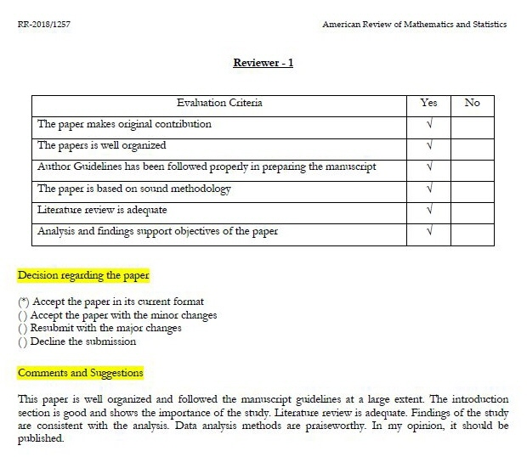

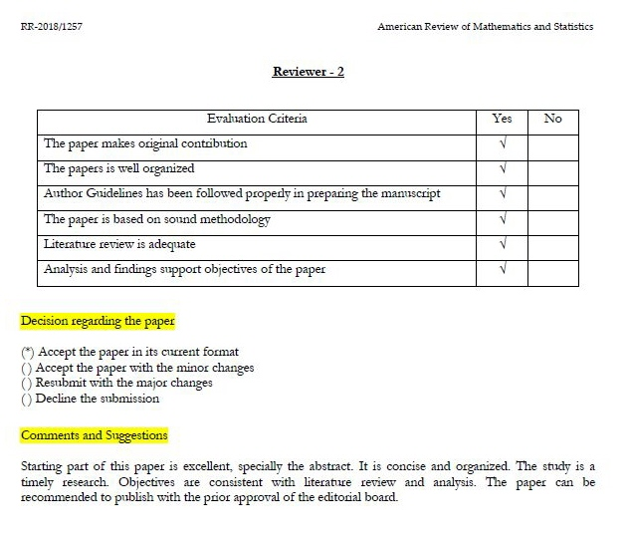

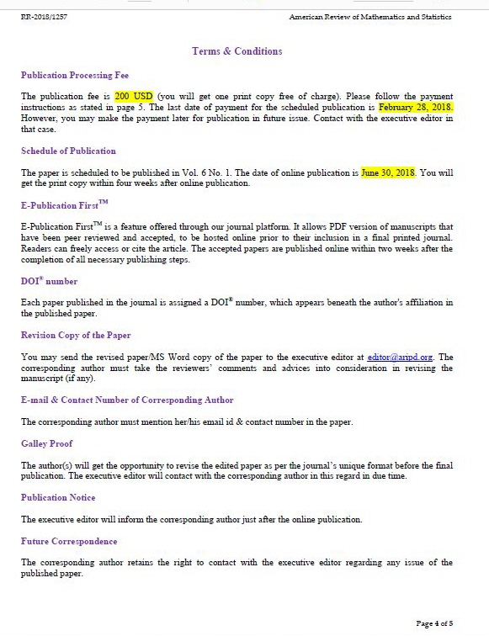

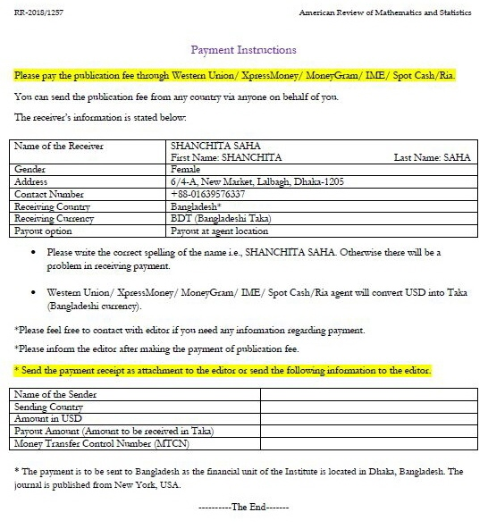

App7.

Forum Mathematicum
https://mc.manuscriptcentral.com/form
Password: Tdenes52
Reviewer:
Jan Hendrik Bruinier (Department of Mathematics, Technische Universität Darmstadt) Number theory, automorphic forms, algebraic geometry.

Forum Mathematicum
From: onbehalfof@manuscriptcentral.com
To: tdenest - tdenest@freemail.hu
Date: 04-24-2018 10:53:18

Dear Dr. Dénes,
Thank you again for submitting your manuscript FORUM.2018.0088 entitled "Dénes type Symmetric Prime Number theorem and its application to proof of the Even Goldbach conjecture" to Forum Mathematicum (FORUM).
I regret that I cannot accept your manuscript for publication in FORUM. This decision must be regarded as final.
Manuscripts submitted to Forum can sometimes fall short for acceptance for publication for a number of reasons. For example, the submitted article may be too specialized and therefore not suitable for the broad readership we enjoy with FORUM. The results from the study may not be novel and innovative, and only a relatively small advance in information can be gained from the submitted work.
Although we appreciate your scientific efforts represented by this work, I regret to inform you that we do not consider this work to be of sufficient interest to our readership to warrant publication.
Thank you for considering Forum for publication of your research.
Best regards
Dr. Jan Bruinier
Editor Forum Mathematicum
----- . ------

Dear Dr. Jan Bruinier
Editor Forum Mathematicum

Of course, I take note of your decision. But the closing sentence of your letter was surprised:
„I regret to inform you that we do not consider this work to be of sufficient interest to our readership”.
I can not imagine what might be of sufficient interest to your readership, if the proof of Goldbach conjecture (which was unproved for 275 years) did not?
Best regards,
T. Dénes

App8.

Moscow J. Comb. Number Th. (via EditFlow)
From: editflow+moscow@ef.msp.org
To: tdenest - tdenest@freemail.hu
Date: 04-27-2018 11:04:27

Dear Professor Dénes,
This message concerns the manuscript
Dénes type Symmetric Prime Number theorem and its application to proof of the Even Goldbach conjecture by Tamás Dénes, submitted to Moscow Journal of Combinatorics and Number Theory.
Some time ago our editors came to the decision that we do not consider in our journal papers in elementary number theory devoted to twin primes problem and Goldbach conjecture.
Unfortunately, we cannot accept your paper for publication.
Sincerely,
Moscow Journal of Combinatorics and Number Theory

App9.

Re: Paper submission for publication
Amer. Journal of Math.
From: ajm@chow.mat.jhu.edu
To: titoktan - titoktan@freemail.hu
Date: 04-30-2018 19:17:53

Dear Professor Dénes,
Thank you for taking the time to submit your work to the AJM. We regret to
inform you that we are unable to publish it.
Thank you again for your interest in the Journal.
Sincerely,
The Editors
Amer. J. Math.

App10.

Decision on your IMRN submission - Manuscript ID IMRN-2018-377
International Mathematics Research Notices
From: onbehalfof@manuscriptcentral.com
To: tdenest - tdenest@freemail.hu
Date: 05-01-2018 17:43:21

Dear Dr Dénes,
Thank you for your recent manuscript submission to International Mathematics Research Notices.
We regret that we cannot accept your paper entitled "Dénes type Symmetric Prime Number theorem and its application to proof of the Even Goldbach conjecture" for publication in IMRN.
With kind regards,
Zeev Rudnick
Principal Editor, IMRN

App11.

Yitang (Tom) Zhang 06.07.2018.

https://www.ucsb.edu/
University of California Santa Barbara
https://www.youtube.com/watch?v=Z5zvhqyO7IM&t=454s

yitang.zhang@math.ucsb.edu

Dear Prof. Zhang!
I am Tamás Dénes a Hungarian mathematician-cryptographer. My basic Complementary prime-sive theorem and its proof has been published in PU.M.A. in 2001. See:
http://www.titoktan.hu/_raktar/_e_vilagi_gondolatok/PUMA-CPS.pdf

This theorem is the basis of my Dénes-type Symmetric Prime Number theorem in 2016, of which the consequence is to prove the Goldbach conjecture. This is included in my paper:
http://www.titoktan.hu/_raktar/_e_vilagi_gondolatok/DT-SymmPrime-theorem.pdf

I have the honor, if you comment on this paper.
Yours sincerely,
Dénes, Tamás

NO ANSWER!!!!

App12.

David Eisenbud
de@math.berkeley.edu

de@msri.org (Algebra & Number Theory Editorial Board Chair)

https://math.berkeley.edu/people/faculty/david-eisenbud

 MATHEMATICS + BERKELEY

Dear Prof. David Eisenbud!
I watched your great video for Goldbach conjecture on YouTube. Your enthusiastic performance gave me the idea to find you with the proof of the Goldbach conjecture.

I am Tamás Dénes a Hungarian mathematician-cryptographer. My basic Complementary prime-sive theorem and its proof has been published in PU.M.A. in 2001. See:
http://www.titoktan.hu/_raktar/_e_vilagi_gondolatok/PUMA-CPS.pdf
This theorem is the basis of my Dénes-type Symmetric Prime Number theorem in 2016, of which the consequence is to prove the Goldbach conjecture. This is included in my paper:
http://www.titoktan.hu/_raktar/_e_vilagi_gondolatok/DT-SymmPrime-theorem.pdf
I have the honor, if you comment on this paper.
Yours sincerely,
Dénes, Tamás
----- . -----

David Eisenbud
From: de@msri.org
To: tdenest@freemail.hu
Date: 06-26-2018 14:05:17

Sorry, but I'm really not an expert (despite the YouTube talk), and I don't have time to work on this subject.
David Eisenbud
Director, Mathematical Sciences Research Institute; and
Professor of Mathematics,University of California, Berkeley
www.msri.org/~de

App13.

Prof. Sir Andrew Wiles
https://www.maths.ox.ac.uk/people/andrew.wiles

Dear Prof. Wiles! 07.08.2018.
My hope is when I write this letter to you, so that you can feel my situation, since you was in a similar situation, when you proved the great Fermat conjecture after 350 years.
I am Tamás Dénes a Hungarian mathematician-cryptographer. My basic Complementary prime-sive theorem and its proof has been published in PU.M.A. in 2001. See:
http://www.titoktan.hu/_raktar/_e_vilagi_gondolatok/PUMA-CPS.pdf

This theorem is the basis of my Dénes-type Symmetric Prime Number theorem in 2016, of which the consequence is to prove the Goldbach conjecture. This is included in my paper:
http://www.titoktan.hu/_raktar/_e_vilagi_gondolatok/DT-SymmPrime-theorem.pdf

So far I have sent my paper to eight mathematical journals (including the Annals of Mathematics journal in which your proof was published). Each journal refused my paper without revision. Yet the Goldbach conjecture was nearly 100 years younger than the great Fermat conjecture and the page number of my proof is approx. 20 percent of you.

I have the honor, if you comment on my paper and if you consider it worthwhile, you would recommend it to a journal.
Yours sincerely,
Dénes, Tamás
NO ANSWER!!!!

App14.

Dear Professor János Pintz, 8/4/2018
https://users.renyi.hu/~pintz/

I am Tamás Dénes, mathematician and cryptographer (I was your student at ELTE in the 1970s).
I started working with primes in connection with cryptography, which resulted in the publication of my Complementary Prime-Sieve theorem and its proof in the PU.M.A. journal in 2001 (http://www.titoktan.hu/_raktar/_e_vilagi_gondolatok/PUMA-CPS.pdf). This theorem serves as the basis for my Dénes-type Symmetric Prime Number theorem, from which the proof of Goldbach’s conjecture follows. This is presented in my next paper: http://www.titoktan.hu/_raktar/_e_vilagi_gondolatok/DT-SymmPrime-theorem.pdf

As one of your main fields of research is Goldbach’s conjecture, it would be an honor to have you review my paper, and, should you consider it worthwhile, recommend it to a journal.
Looking forward to your reply,
Sincerely,
Tamás Dénes
NO ANSWER!!!

App15.

Int. J. Number Theory (IJNT)
From: em@editorialmanager.com
To: Tamás Dénes - tdenest@freemail.hu
Date: 10-13-2018 7:19:01

Dear Dr Dénes,
I'm afraid your submission entitled "Dénes type Symmetric Prime Number theorem and its application to proof of the Even Goldbach conjecture" is unacceptable for International Journal of Number Theory.
Thank you for your interest in this journal.
Kind regards,
Michael Filaseta
Managing Editor
International Journal of Number Theory

----- . -----

From: tdenest@freemail.hu
To: Int. J. Number Theory (IJNT) - ijnt@wspc.com
Date: 10-13-2018 17:49:12

Dear Dr. Michael Filaseta,
Of course, I accept your decision, but my question is why?
Sincerely yours,
T.Dénes
----- . -----
Michael Filaseta
From: filaseta@mailbox.sc.edu
To: tdenest - tdenest@freemail.hu
Date: 10-16-2018 9:53:42

Unfortunately, I do not have the time to explain in detail why every rejected paper is rejected for IJNT. But I can tell you (i) there were errors and (ii) if there weren’t errors, we would still have rejected the paper. The latter is because papers that solve long standing problems are rejected on the basis that they should be submitted instead to one of the top two or three research journals in the world, where articles routinely are assigned more than one referee to look over such papers in detail. IJNT is not the place for such results.
Kind regards,
Michael Filaseta
----- . -----

Dear Michael Filaseta! (but I note you avoided my salutation)
I appreciate your quick response and I do not want to kidnap your time. I have only one question: Which one would be the „one of the top two or three research journals in the world” which you target in your letter?

App16.

Professor Kálmán Győry and Márton Szikszai PhD

From: tdenest@freemail.hu
To: gyory@science.unideb.hu
Date: 11/18/2018 7:07:52 AM

Dear Professor,
I have been interested in the BIG challenges of prime numbers for many years. In 2001, I published my Complementary Prime-Sieve (CPS) theorem and its proof (see: http://www.titoktan.hu/_raktar/_e_vilagi_gondolatok/PUMA-CPS.pdf )
I was not disturbed by that my achievement remained unnoticed, because I was convinced that the reward of problem solving is the IDEA itself.
On the other hand, I had the feeling that the CPS theorem could bring a new approach into the world of prime number research, so I examined its application to problems yet unsolved, and seemingly unsolvable via traditional methods. This is how I arrived at my Symmetric Prime Number theorem, based on CPS, from which the proof of Goldbach’s conjecture simply follows indeed.
I truly hope that you will not be scared off by my request to read and review my 7-page article attached. Thank you for your time,
Tamás Dénes
----- . -----
From: gyory@science.unideb.hu
To: Me - tdenest@freemail.hu
Cc: szikszai.marton - szikszai.marton@science.unideb.hugyory - gyory@science.unideb.hu
Date: 12/4/2018 11:10:36 AM
Dear Colleague Tamás Dénes,
Please excuse my late reply. Unfortunately, I am very busy, so I have asked one of my most talented young teacher colleagues Márton Szikszai to review your manuscript. Below you will find his review, which says that you should continue working on your proof. If you find it necessary, you can carry on your correspondence directly with him; you’ll find his e-mail address below.
Best regards, Kálmán Győry
-------- Forwarded message --------
Subject: | mathematical observations
Date: | Tue, 4 Dec 2018 08:02:11 +0100 (CET)
From: | Márton Szikszai<szikszai.marton@science.unideb.hu>
To: | Kalman Gyory<gyory@science.unideb.hu>
Dear Tamás Dénes, Upon the request of Professor Győry, I reviewed your paper titled “Dénes type Symmetric Prime Number theorem and its application to proof of the Even Goldbach conjecture.” My comments are as follows: On page 3, you try to argue indirectly that m<N exists, that both elements of the (p,q)=(N-m,N+m) pair are prime numbers. This can be negated the following way: for any m<N it is true that maximum one element of the (p,q)=(N-m,N+m) pair is a prime number. The following cases are possible: both N-m and N+m are composite numbers, or N-m is a prime and N+m is a composite, or N-m is a composite and N+m is a prime. In your paper, you only consider the second case, which is not sufficient for proving your argument. It is easy to see that your method is suitable for proving the third case as well, due to reasons of symmetry. At the same time, I cannot see how the option of the two composites could be excluded with the complementary prime sieve. Please reconsider this point carefully, and try to adjust your proof accordingly.
Kind regards, Márton Szikszai
----- . -----
From: tdenest@freemail.hu
To: gyory@science.unideb.hu
Date: 12/5/2018 9:57:06 AM

Dear Professor Győry,
Dear Kálmán,
Thank you very much for your reply, which has given me great pleasure, as my paper that has been sent out to various mathematicians and international journals of mathematics over the past year has been mostly left without even an answer. Even when I received a reply, it was rejected without a review.
I perfectly understand that besides your numerous engagements you don’t have time for an itemized analysis of a paper consisting of a pure proof. I’ve heard this from many already, but none of them would do the gesture you did, to hand it over for review to a talented student considered suitable for the task. Thank you for this!
Márton Szikszai’s comments were of a great help, so now I will set out to address those.
As soon as any progress is made, I shall inform you. Of course, I will get in touch with Márton as well.
Thank you very much,
Tamás D.
----- . -----
From: tdenest@freemail.hu
To: szikszai.marton@science.unideb.hu
Date: 1/17/2019 5:16:02 AM

Dear Márton,
Thank you for your valuable comments. Based on these, I have amended my proof with the originally missing cases II and III. Actually, proving the third case would have been extremely complicated based on my complementary prime sieve theorem, so I reached out to an entirely new idea, basing it on Chebyshev's theorem. Then, with the help of a lemma, I also provided the proof of a stronger case.
I am looking forward to your comments on this new proof.
Thank you and best regards,
Tamás D.
----- . -----
From: szikszai.marton@science.unideb.hu
To: D.T. - tdenest@freemail.hu
Date: 2/7/2019 10:50:30 AM

Dear Tamás,
I still disagree with the proof. In case III, there is too much freedom for m-N. Actually, m-N is minimum 1 and maximum N-2; namely, the case m-N=0 would mean that N is an odd prime (2 is excluded because of the conditions), while m-N=N-1 would mean that p-{N-} = 1, which is not possible. Consequently, it is possible that on one side there are only composite numbers explored, just as on the other side.
Unfortunately, I do not have any further proposals on how to proceed.
Kind regards, Márton Szikszai
----- . -----

From: tdenest@freemail.hu
To: szikszai.marton@science.unideb.hu
Date: 2/9/2019 12:18:47 PM

Dear Márton,
I am always inspired by your ideas. Although the issues you have raised could be solved with some minor amendments, I have managed to find a much shorter proof instead of this, which I attach hereby.
Thank you, Tamás D.
----- . -----

From: szikszai.marton@science.unideb.hu
To: D.T. - tdenest@freemail.hu
Date: 2/9/2019 1:10:13 PM

Dear Tamás,
I still maintain my position that this proof cannot be completed by elementary means, and I continue to recommend that you review the proof of the odd Goldbach’s conjecture from Harald Helfgott. It is far from trivial. If you cannot manage to simplify that, it is hopeless to solve the even case with simple prime-theory relationships.
Kind regards, Márton Szikszai
----- . -----
From: tdenest@freemail.hu
To: szikszai.marton@science.unideb.hu
Date: 2/18/2019 4:59:36 PM

Dear Márton,
Let me summarize the steps taken so far. First, you brought to my attention that the indirect proof was incomplete. As a result, I broke down the proof into cases I, II, and III, out of which cases I and II were already included in the original proof. That is, the proof – or, for indirect proof, the exclusion – of case III was missing. The argument for case III is included in (s28). This states exactly that in all rows of Table 2, the values p(N-) and p(N+) are composite values. This is refuted if, for any N, THERE IS AT LEAST ONE row for which this is not met. I proved that for any N that corresponds to the theorem, at least rows N-3 and N-2 are always like that.
Best regards, Tamás D
----- . -----
From: szikszai.marton@science.unideb.hu
To: D.T. - tdenest@freemail.hu
Date: 2/21/2019 10:19:03 AM

Dear Tamás,
Based on my last quick read of your proof, I still found that it was erroneous, but I do not see any reasons why I could not be mistaken, in which case everything is fine, and the paper is ready for publishing. In light of your arguments I would like to alter the expression “is erroneous” to “I am skeptical about its correctness,” and I will leave you to decide about any further steps to be taken regarding these results.
Kind regards, Márton Szikszai
----- . -----
From: tdenest@freemail.hu
To: gyory@science.unideb.hu
Date: 2/23/2019 7:27:46 AM

Dear Professor Győry,
Dear Kálmán,
Hereby I inform you that, in accordance with your suggestion, I consulted your colleague Márton Szikszai. In several rounds, he provided me with constructive comments on the completion of my proof, which I have taken into account to amend my paper. Thus, I’m sending you my paper adjusted accordingly.
I would be honored if you provided me with your recommendation for having it published in an English language journal.
Thank you very much, Tamás D
----- . -----

From: gyory@science.unideb.hu
To: D.T. - tdenest@freemail.hu
Cc: gyory - gyory@science.unideb.huszikszai.marton - szikszai.marton@science.unideb.hu
Date: 2/23/2019 10:26:15 PM

Dear Tamás,
Unfortunately, I cannot write what you would like me to, meaning, that you have managed to prove Goldbach’s conjecture. My friendly attitude is overruled by scientific truthfulness.
Márton Szikszai has asked me to relieve him from his role. I had no choice but to do that. Namely, we do not believe that this path of yours could lead to the proof of the conjecture. I actually do not believe that the conjecture can be proven via an elementary proof.
If you think so, you may submit your article for publication, but I would not like to play a part in that because of the expected response.
Yours truly, Kálmán
----- . -----
From: tdenest@freemail.hu
To: gyory@science.unideb.hu
Date: 2/24/2019 7:24:26 AM

Dear Kálmán,
In any case, thank you for your support and Márton’s constructive suggestions.
Even if I do not understand it, I accept that “you do not believe” in my proof. I continue to THINK that mathematics may only be a matter of FAITH when establishing axioms, but otherwise all proofs must meet two criteria: completeness and logical infallibility.
As for the first criterion, it was specifically Márton, who brought my attention to this, and I fulfilled this condition in accordance with his suggestions. As for the second criterion, he did not formulate any objections in his last letter.
Dear Kálmán, you still have my undiminished respect, I just don’t understand what your words “we do not believe that this path of yours could lead to the proof of the conjecture” mean in mathematical terms.
If the proof is erroneous, it can be easily demonstrated, can’t it?
Thank you very much for your well-intentioned efforts,
Yours truly, Tamás D
----- . -----
From: gyory@science.unideb.hu
To: D.T. - tdenest@freemail.hu
Cc: szikszai.marton - szikszai.marton@science.unideb.hugyory - gyory@science.unideb.hu
Date: 2/24/2019 10:18:01 AM

Dear Tamás,
I understand that you were not pleased with my letter. I am sorry for using the word “believe.” It would have been better to say that we do not think it is possible to provide a complete and correct elementary proof for this conjecture.
Yours truly, Kálmán
----- . -----
From: tdenest@freemail.hu
To: gyory@science.unideb.hu
Date: 2/24/2019 11:28:42 AM

Dear Kálmán,
It would be a misunderstanding to think that I was emotionally affected by your letter. After all, it was you writing in your previous mail that your “friendly attitude is overruled by scientific truthfulness.” Which I agree with 100%.
Probably this is why I DO NOT UNDERSTAND what it means in mathematics that “we don’t believe” or “we think it is not possible by elementary means.” That is, I’m missing the scientific truth here, saying for example that “here and here the proof is erroneous,” or “the proof of one of the arguments is missing,” etc.
Perhaps I misunderstood Márton, having taken into consideration all his mathematical comments and correcting the proof accordingly, because I did not find any MATHEMATICAL objections in his last letter, so I assumed that THERE WERE NONE.
Naturally I understand that you don’t have time and also that I used an extraordinary, new approach, which is suspicious of a person who doesn’t have a name in mathematical circles. Yet, this is what a review from an expert of great knowledge and prestige would compensate, pointing out the mistakes in the mathematical proof, if any.
Best regards, Tamás D

App17.

From: D.T. <tdenest@freemail.hu>
Sent: Tuesday, March 26, 2019 2:41:27 PM
To: Endre Szemeredi
Subject: Into the hands of Professor Endre Szemerédi
Dear Professor Endre Szemerédi,
I’m turning to you because of your mathematical credo elaborated in a TV interview, in which you said: “It is not the theorem that counts, but the method.” To me, your conclusion is even more important, namely that numerous gigantic mathematicians have tried solving difficult problems without success, just because the method they used was not suitable for finding a solution, however ingenious the mind would have been. Thus, the proof of these almost hopeless-looking conjectures unsolved for centuries is sometimes not dependent on the greatness of the mathematician, but the inadequacy of the long-established methods used.
I think I understand your above credo well, if I interpret it as the explanation for the cases, when someone arrives, who does not fully possess all the information related to the existing toolset, and does not handle it in a brilliant way, but approaches the problem with the openness of a child, from an entirely new direction, and successfully arrives at solution.
This is what happened to me as well, similarly to you in many aspects, when I proved my Symmetric Prime Number theorem (see: http://www.titoktan.hu/_raktar/_e_vilagi_gondolatok/DT-SzimmPrimTetel-rovidbiz.pdf) based on my Complementary Prime Sieve theorem (see: http://www.titoktan.hu/_raktar/_e_vilagi_gondolatok/PUMA-CPS.pdf) published in 2001 (which was otherwise left completely unnoticed).
Although this was not my original purpose, I was astonished to see that the even Goldbach’s conjecture simply follows from my theorem. I sent my article to several international number theory journals, but, most likely due to the line of thought described above, they were so scared of it, that they did not even consider it for review, let alone for publication.
I truly hope that due to the “spiritual kinship” I assume you and I share, you will understand my situation, and do me the honor of sending me your comments regarding my 8-page article.
Truly yours,
Tamás Dénes, mathematician-cryptographer
http://www.titoktan.hu/DenesTamas-eletrajz.htm

From: szemered@cs.rutgers.edu
To: D.T. - tdenest@freemail.hu
Date: 4/1/2019 9:11:53 PM

Dear Tamás,
I am very sorry I cannot address this proof. Lately I have not been dealing with mathematics due to health issues.
I wish you all the best, and please accept my apologies.
Best regards, Endre

R E F E R E N C E S

Dénes, Tamás 2001: Complementary prime-sieve
PUre Mathematics and Applications, Vol.12 (2001), No. 2, pp. 197-207 http://www.titoktan.hu/_raktar/_e_vilagi_gondolatok/PUMA-CPS.pdf http://www.titoktan.hu/_raktar/_e_vilagi_gondolatok/KomplementerPrimszita.pdf

Dénes, Tamás 2017: Dénes type Symmetric Prime Number theorem and its application to proof of the Even Goldbach conjecture
http://www.titoktan.hu/_raktar/_e_vilagi_gondolatok/DT-SymmPrime-theorem.pdf
http://www.titoktan.hu/_raktar/_e_vilagi_gondolatok/DT-SzimmPrimTetel-rovidbiz.pdf

Dénes, Tamás 2018a: Application of the Dénes type Symmetric Prime Number theorem to proof of there exist infinitely many primes of the form n²+1
http://www.titoktan.hu/_raktar/_e_vilagi_gondolatok/DT-SymmPrime-theorem-N2%2B1.pdf

Dénes, Tamás 2018b: Proof of the Twin prime conjecture
http://www.titoktan.hu/_raktar/_e_vilagi_gondolatok/DT-Twinprime-conj-proof.pdf

Dénes, Tamás 2018c: Proof of the existence of prime number between successive squares
http://www.titoktan.hu/_raktar/_e_vilagi_gondolatok/DT-Prime-between-successive-squares-proof.pdf

Erdős Pál, 1993: Előadás, Eötvös Lóránd Tudományegyetem, Gólyavár, Budapest,
https://www.youtube.com/watch?v=0ygn6yFKOJo&t=20s

Pintz, János (Budapest): LANDAU’S PROBLEMS ON PRIMES,
http://bsmath.hu/~pintz/pjapr.pdf

Pintz János, 2016: Otthonosan a prímek világában, Beszélgetés Pintz János akadémikussal, (az interjút készítette Staar Gyula), Természet Világa, Budapest, 2016. július
http://www.termeszetvilaga.hu/szamok/tv2016/tv1607/pintz.html

Snyder, Virgil, 1912: The fifth International Congress of Mathematicians, Cambridge, 1912. Bull. Amer. Math. Soc. 19 (1912), no. 3, 119.

Szemerédi Endre, 2014: Ha már matematikus lett, Beszélgetés Szemerédi Endre Abel-díjas gráfelmélésszel (az interjút készítette: Staar Gyula), Természet Világa, Budapest, 2014. június
http://www.termeszetvilaga.hu/szamok/tv2014/tv1406/staar.html

Zhang, Yitang 2014: Bounded gaps between primes, Annals of Mathematics, Volume 179 (2014) Pages 1121-1174, https://annals.math.princeton.edu/2014/179-3/p07

